Scoreable Procedures

Create Competition
Owner | Scoreable
Responsible | Club Competition Manager
Step | Screenshot
1. Add Competition  Open Scoreable Event Managment and click “Add Competition” | 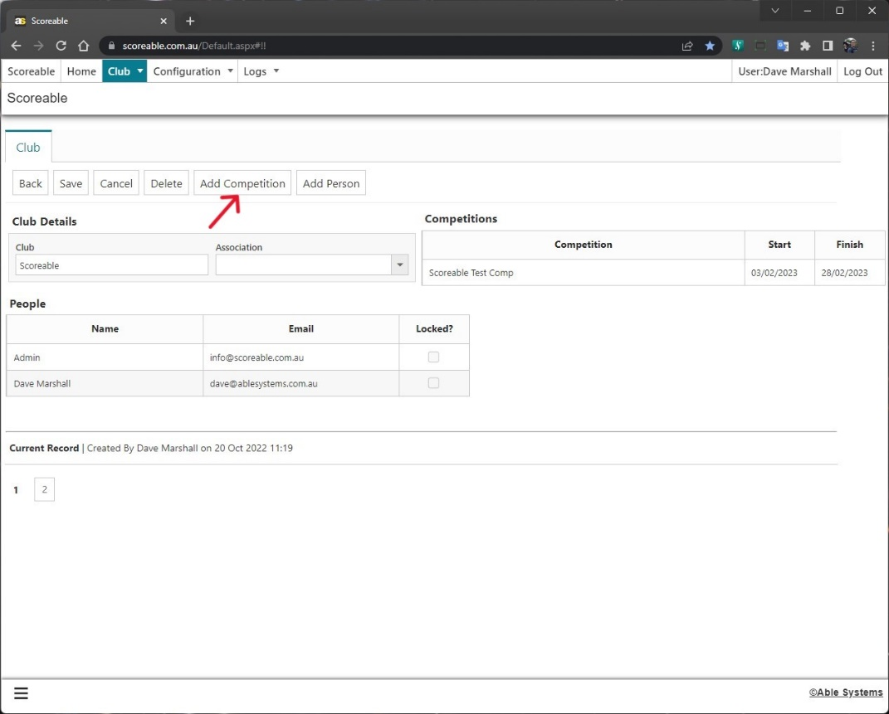
2. Competition Details  Populate fields and click “Save” | 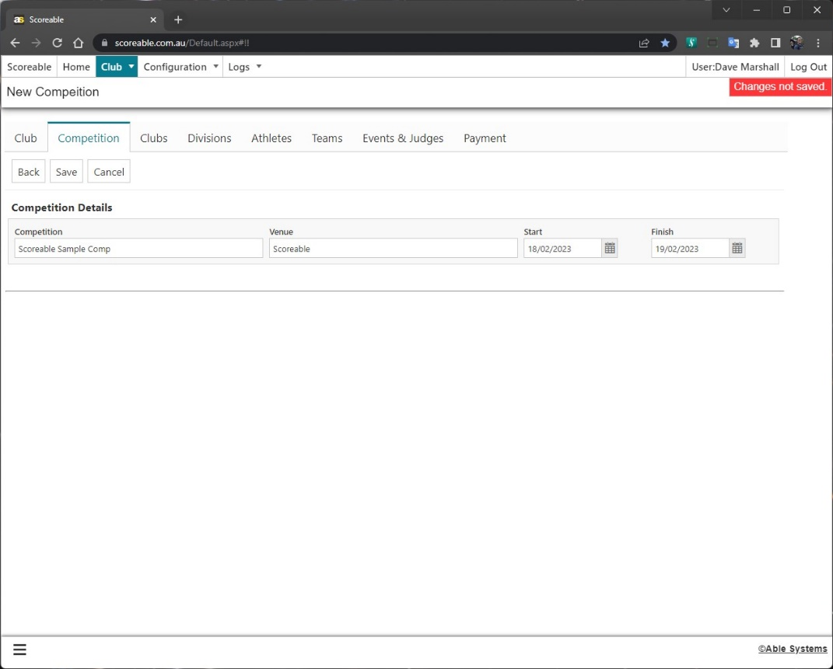
3. Export Config  Click “Export Config” to download a Competition Configuration file | 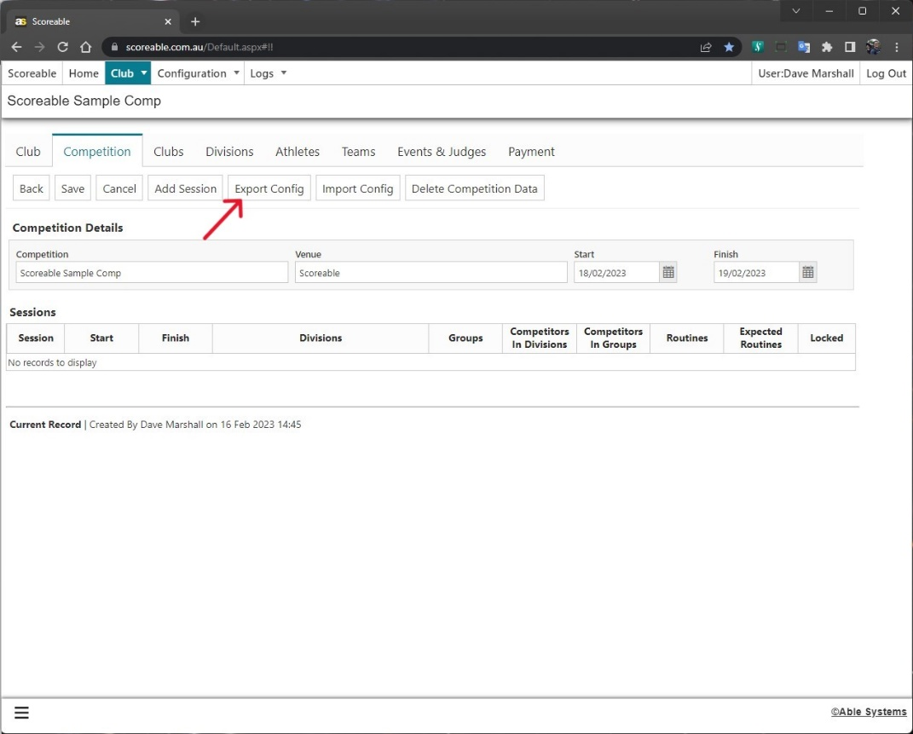
4. Config File  Open the Config file and populate the sheets from left to right  Competition sheet | 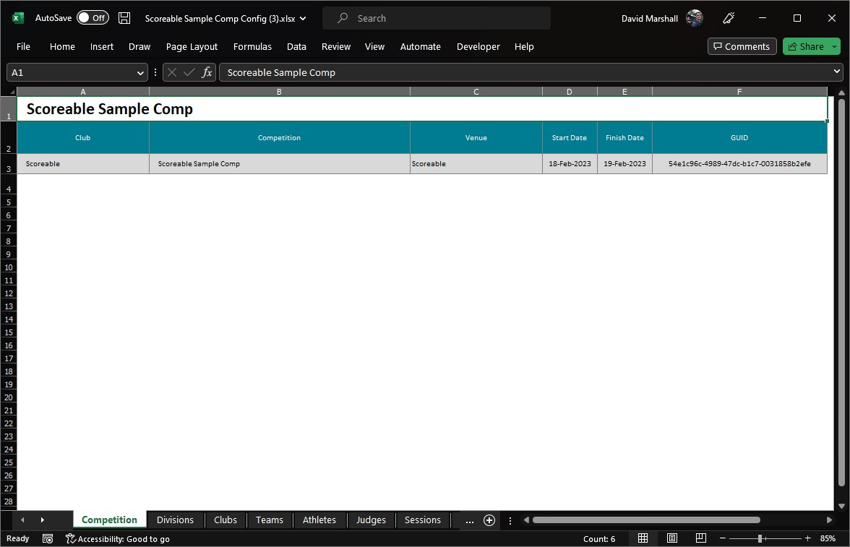
5. Config - Divisions  Divisions sheet | 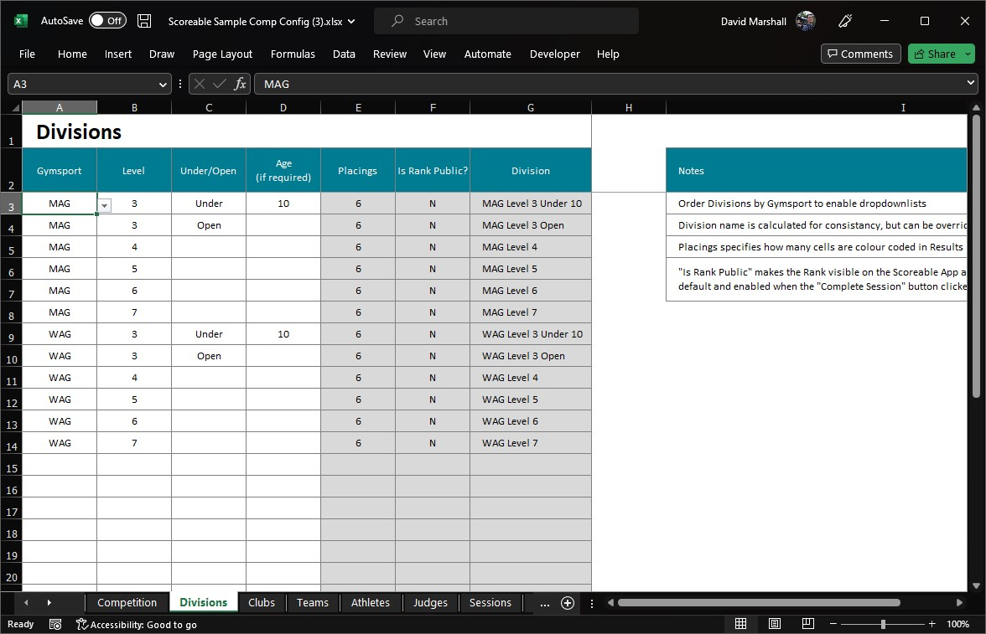
6. Config - Clubs  Clubs sheet | 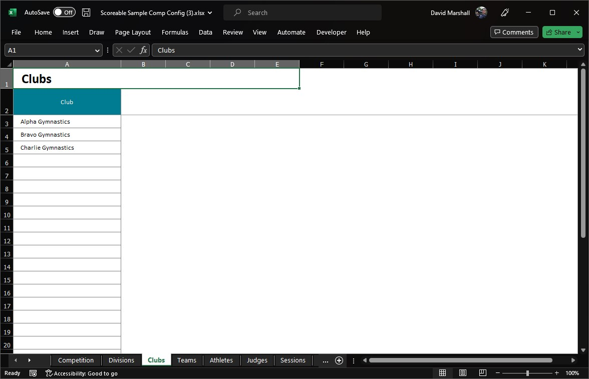
7. Config - Teams  Teams sheet  Note: Teams aren’t required and can be left blank | 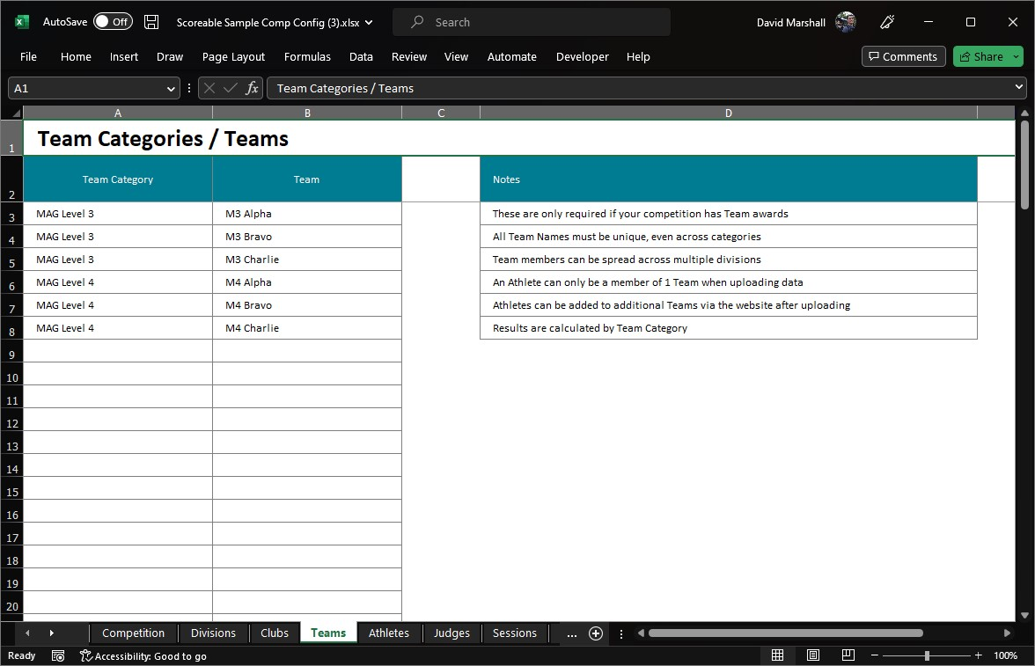
8. Config - Athletes  Athletes sheet  Note: Copy/pasting data is ok, but make sure Clubs, Divisions and Teams match the values in their respective sheet. Use the in-cell dropdown if unsure | 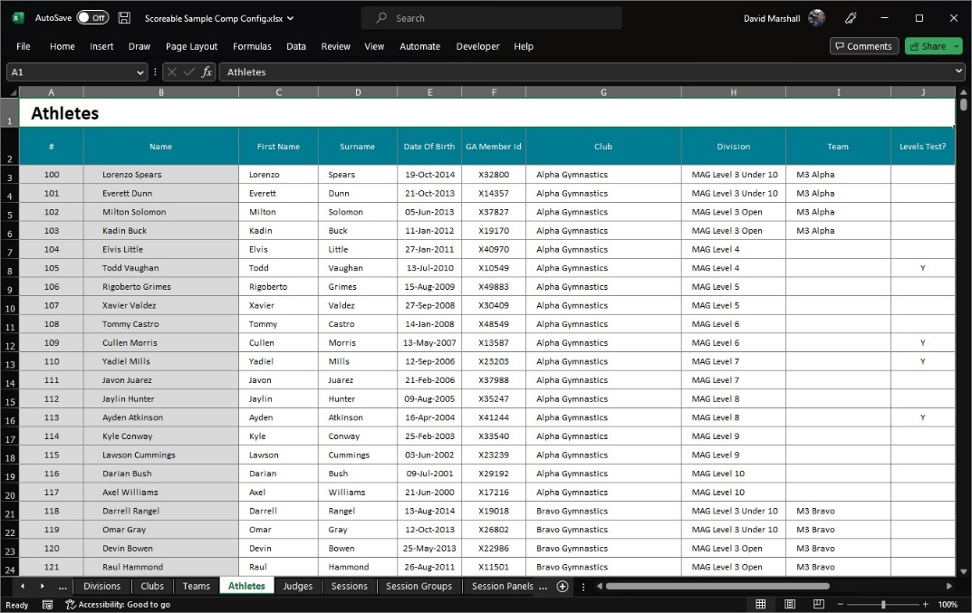
9. Config - Judges  Judges sheet | 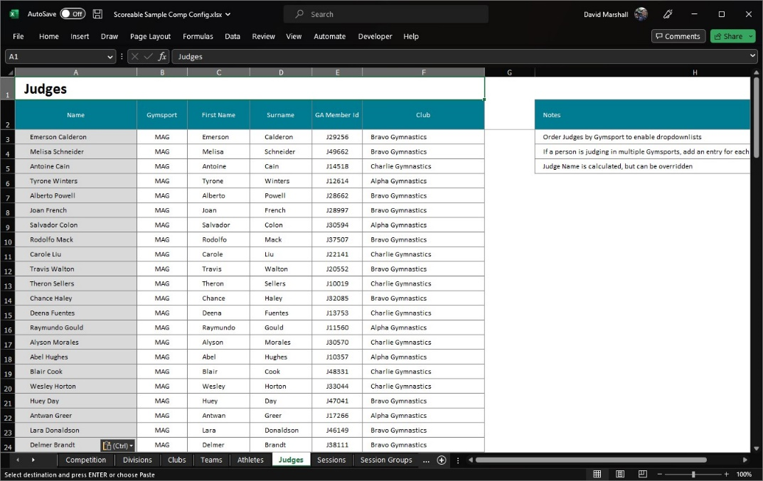
10. Config - Sessions  Sessions sheet | 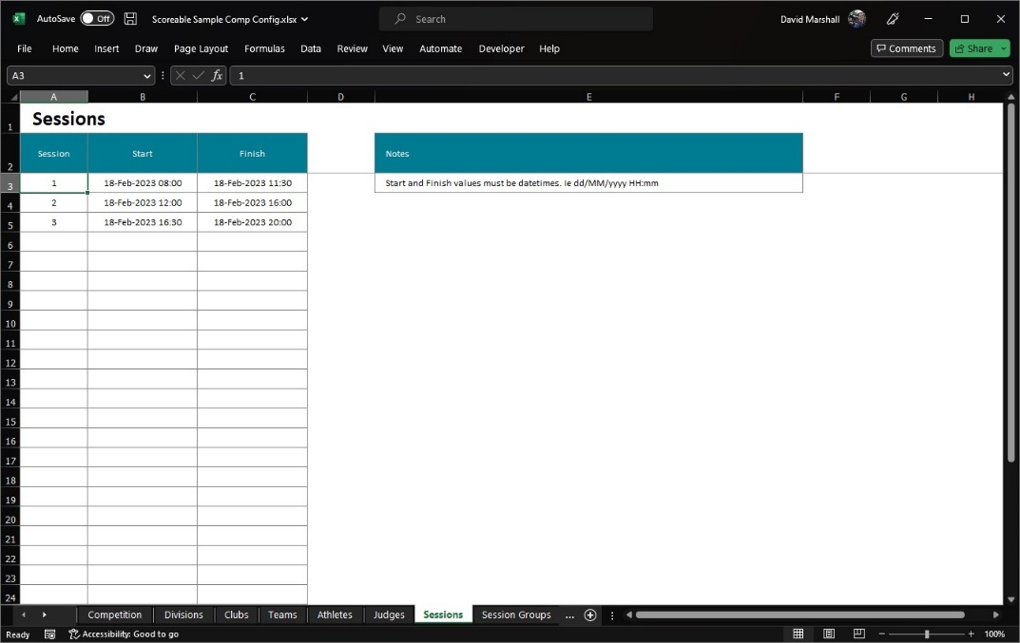
11. Config - Groups  Session Groups sheet | 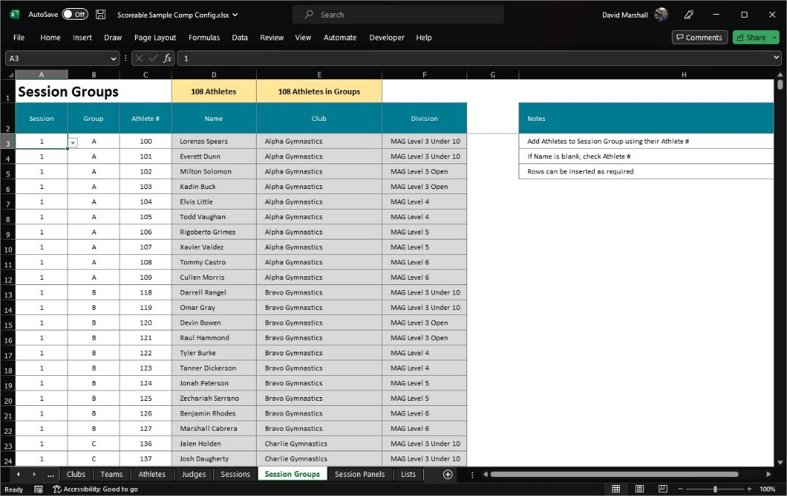
12. Config - Panels  Session Panels sheet | 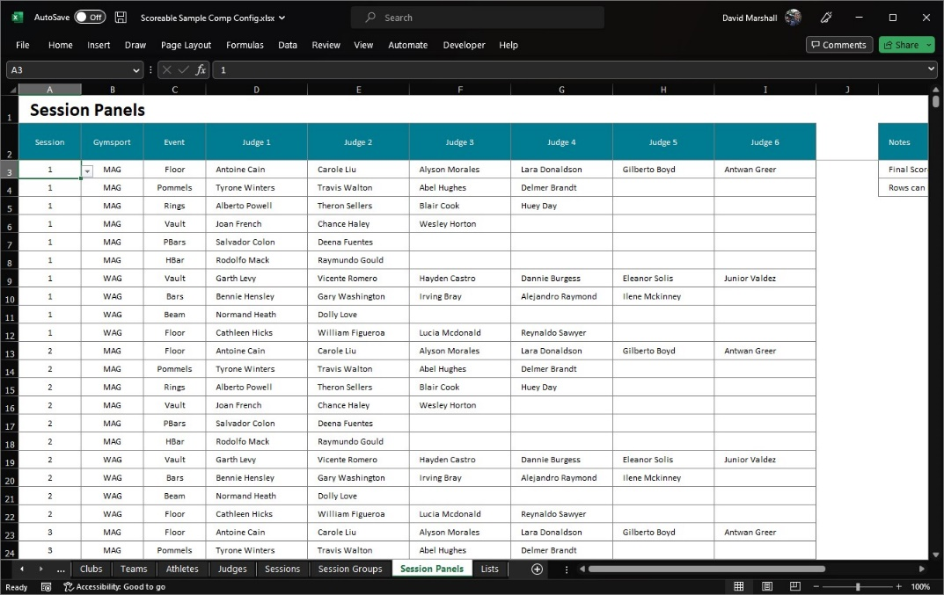
13. Import Config  On the Competition tab, click “Import Config” and upload the saved config file | 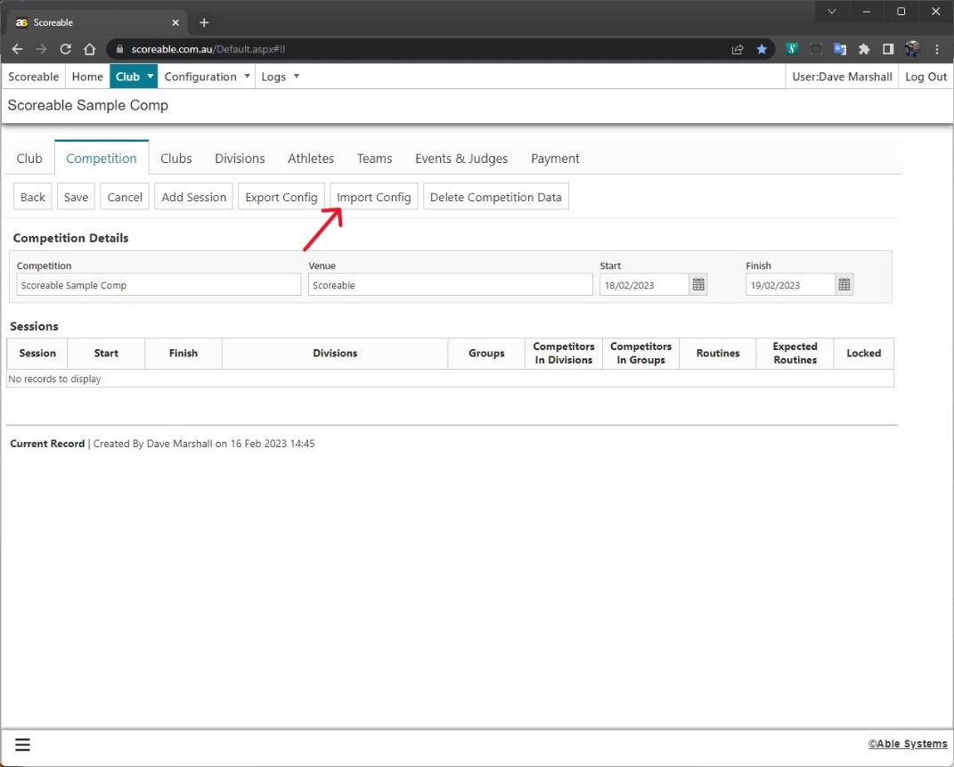
14. Competition  If the upload is successful, you should see the Competition Session details | 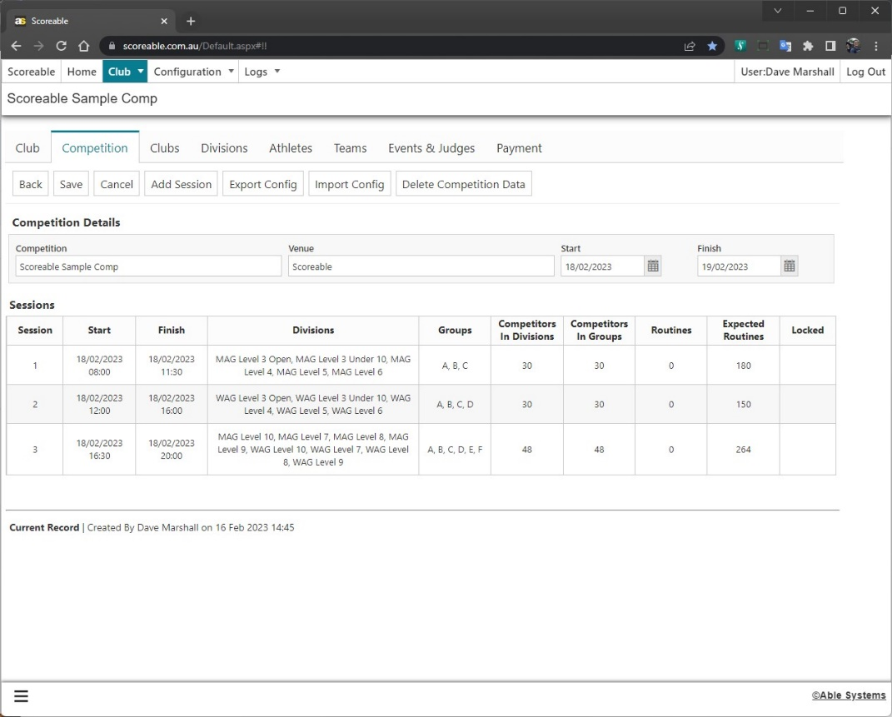
15. Clubs  Check the Club tab and verify the Athlete numbers are accurate  If the number of Club Athletes is incorrect, check that the Club assigned to the Athlete in the Config file matches the name in the Club sheet. Use the in-cell dropdown if needed.  Once corrected, reupload the Config file | 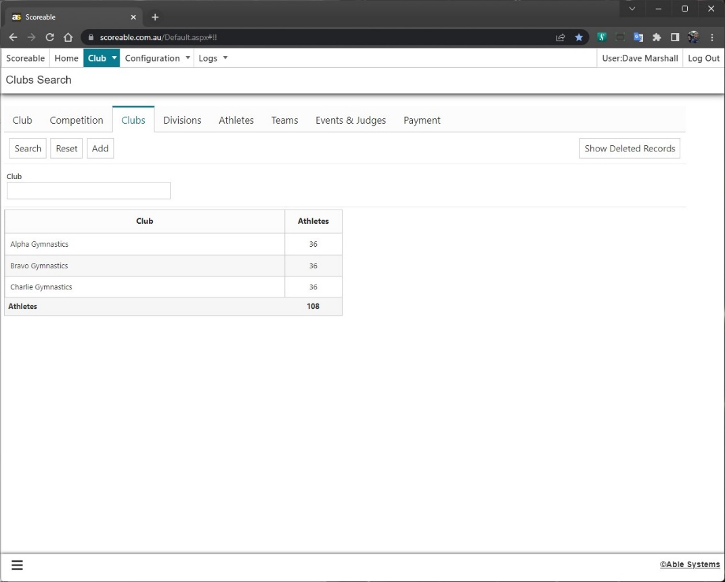
16. Divisions (set Events with 2 Routines)  Check the Division tab and update any Division Events that require 2 routines to be competed  Final Score Calculations:  Best - Highest score of the 2 routines  Average - Average score of the 2 routines  Combine Deductions - Deductions are  Note: WAG Vault defaults to 2 Routines - Best | 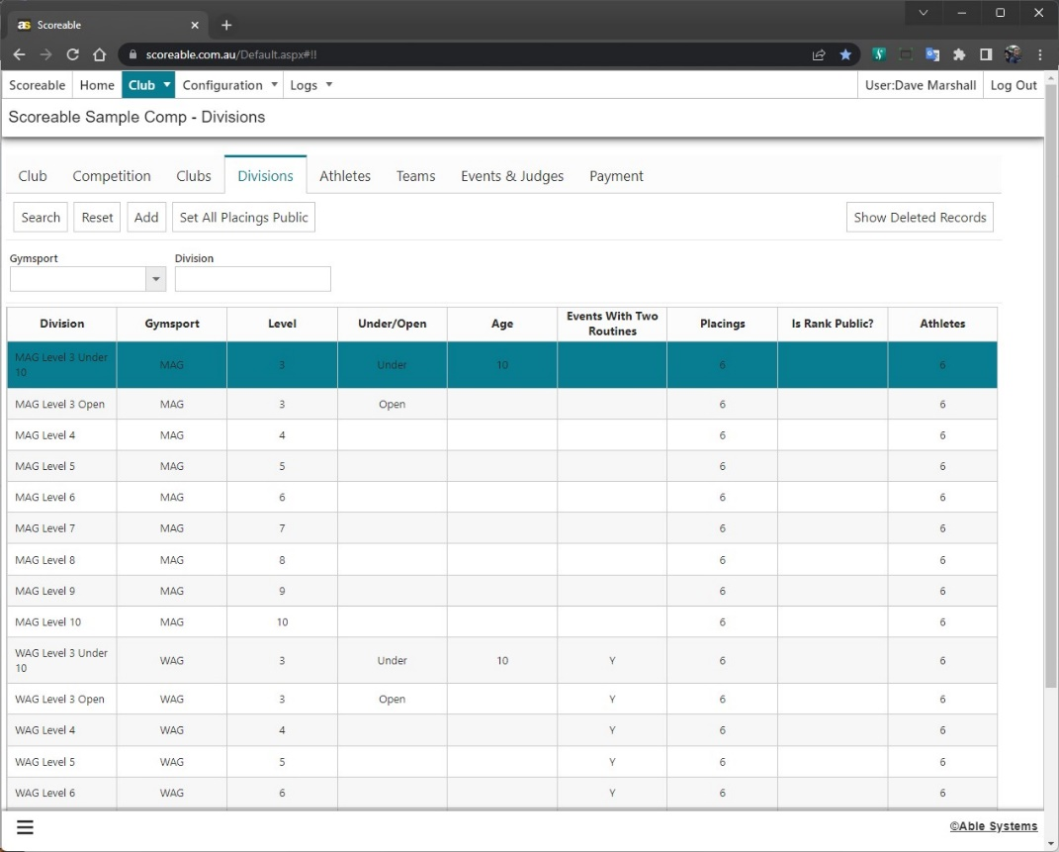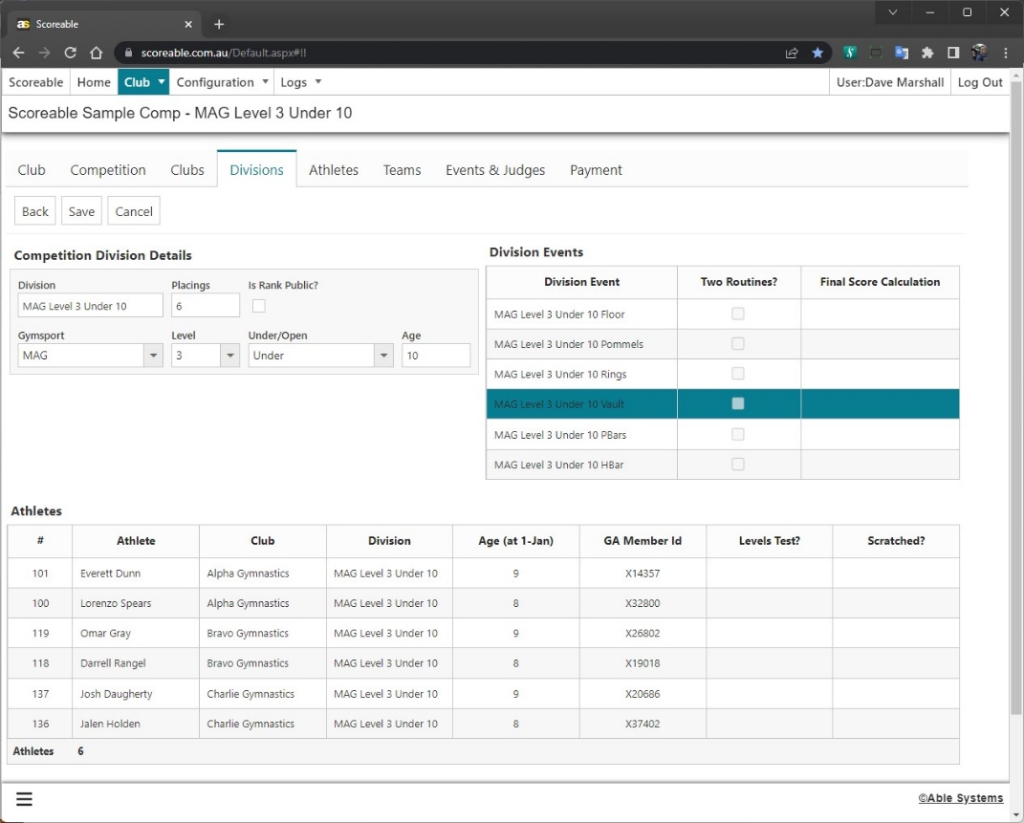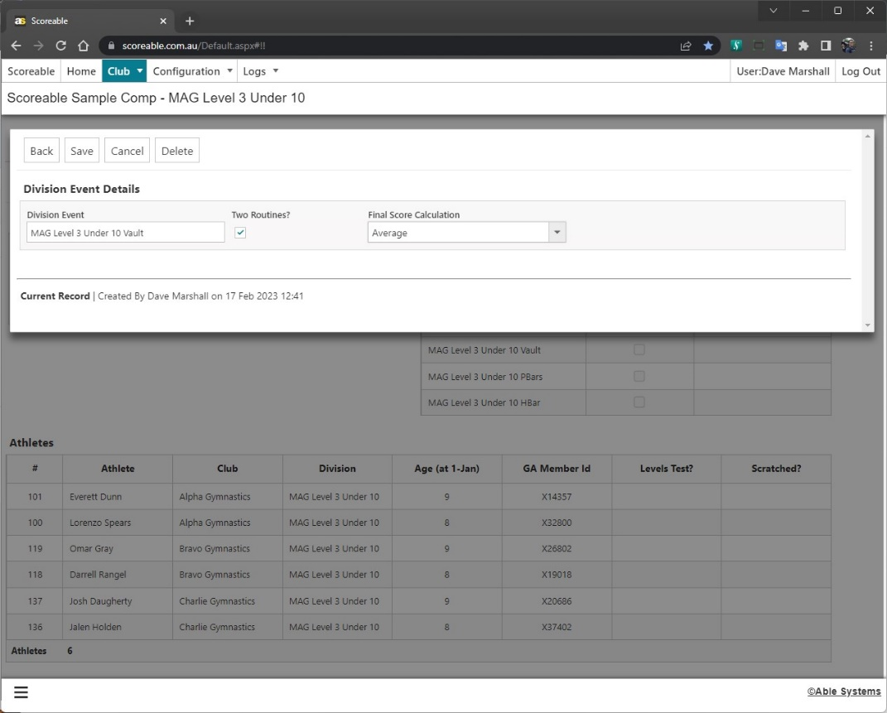
17. Athletes  Check the Athletes tab | 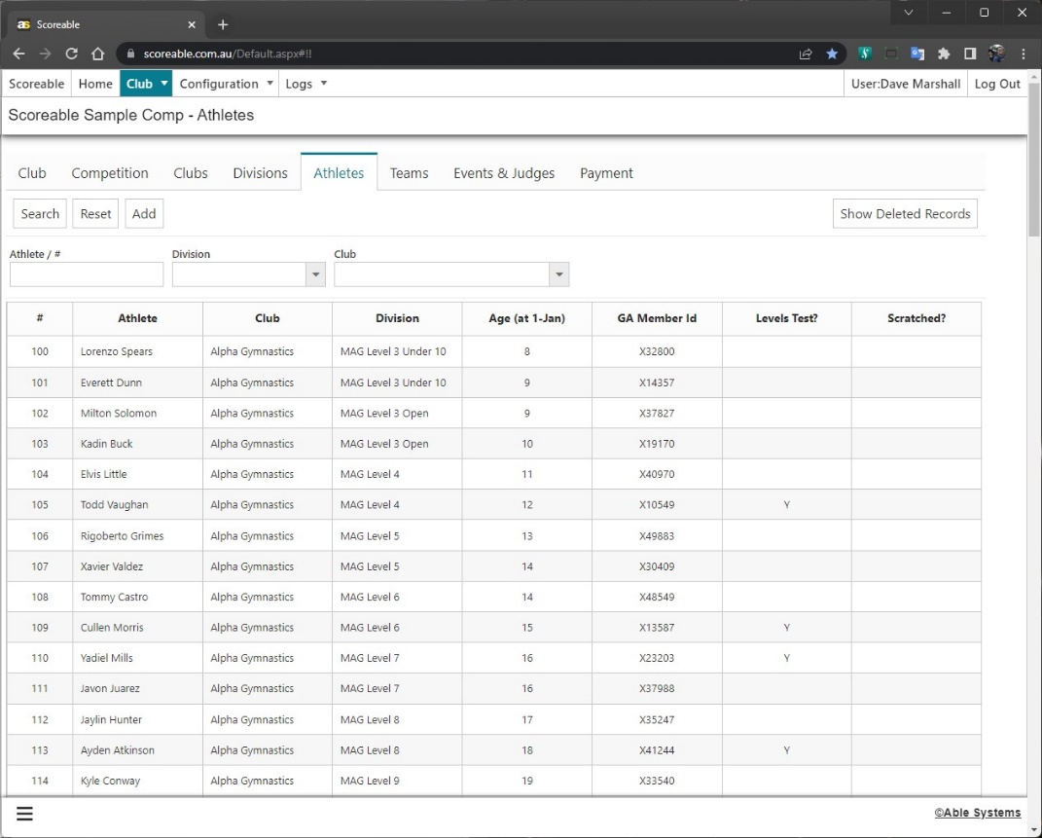
18. Teams  Check the Teams tab | 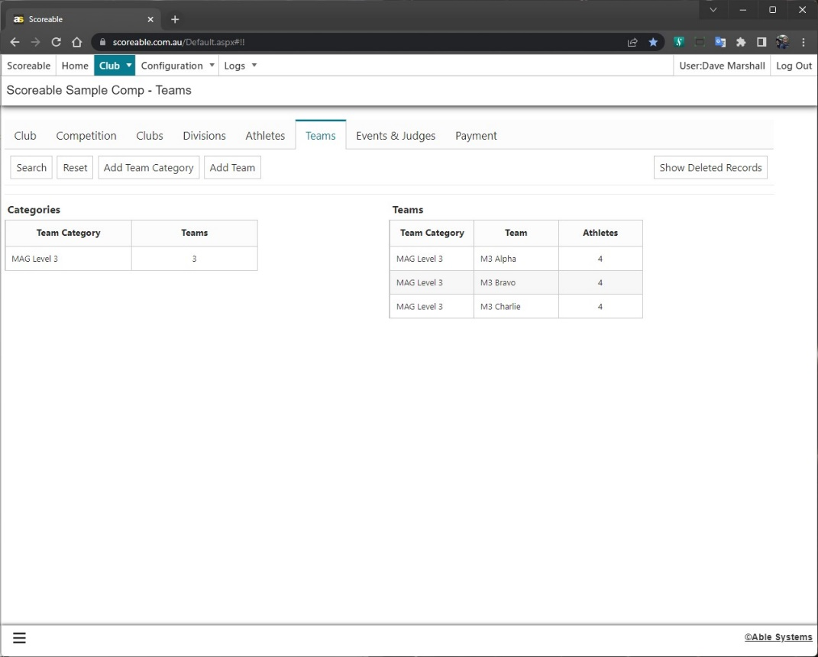
19. Events & Judges  Check the Events & Judges tab  Note: Events with 2 routines can also be checked and updated here | 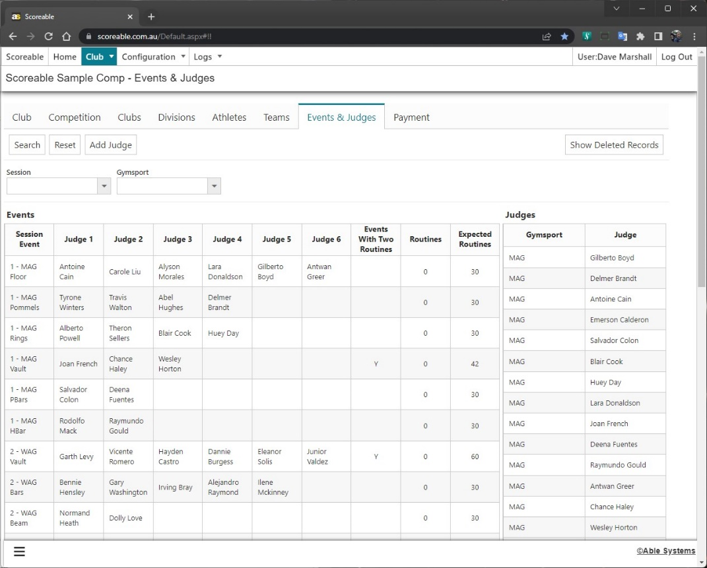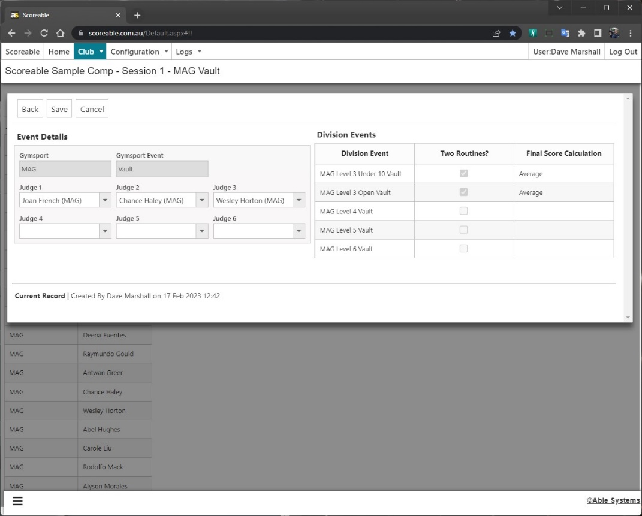
20. Payment  Once everything is correct, pay for the Competition on the Payment tab to enable Scoring  If you can’t pay via PayPal or a Credit Card, click Create Invoice to export a file with bank transfer details. Please email us the remittance so we can update the Competition  The “Enable Sponsor Logos?” checkbox will increase the cost per competitor, but you will be able to upload Primary and Secondary Sponser logos which will display on Scoreboards  You can also Enable Sponsor Logos after the base payment has been made, but will have to pay the difference to reenable Scoring  Note: You can re-upload the config file after payment has been made. If the number of Competitors increases, you’ll have to pay the difference to reenable Scoring | 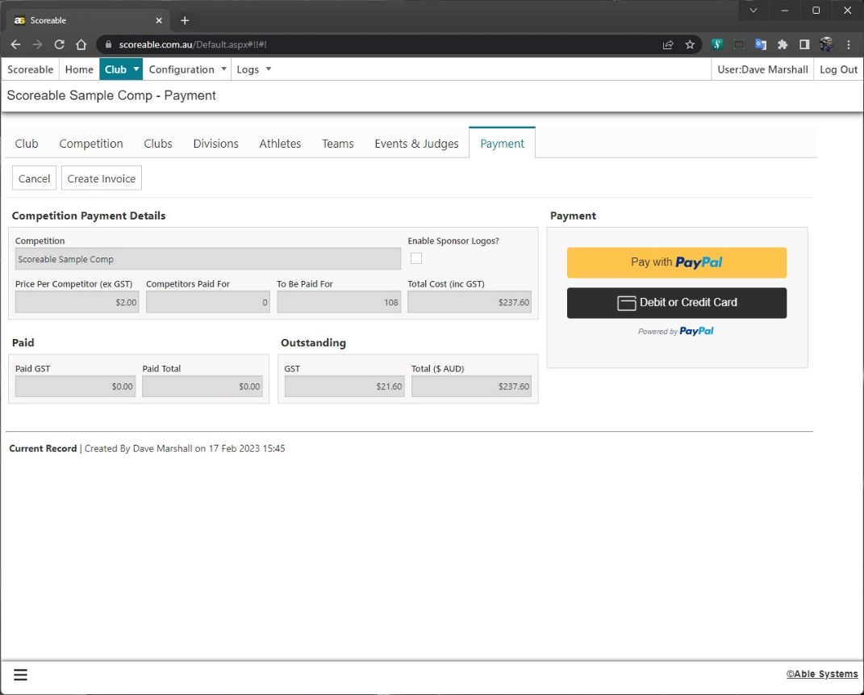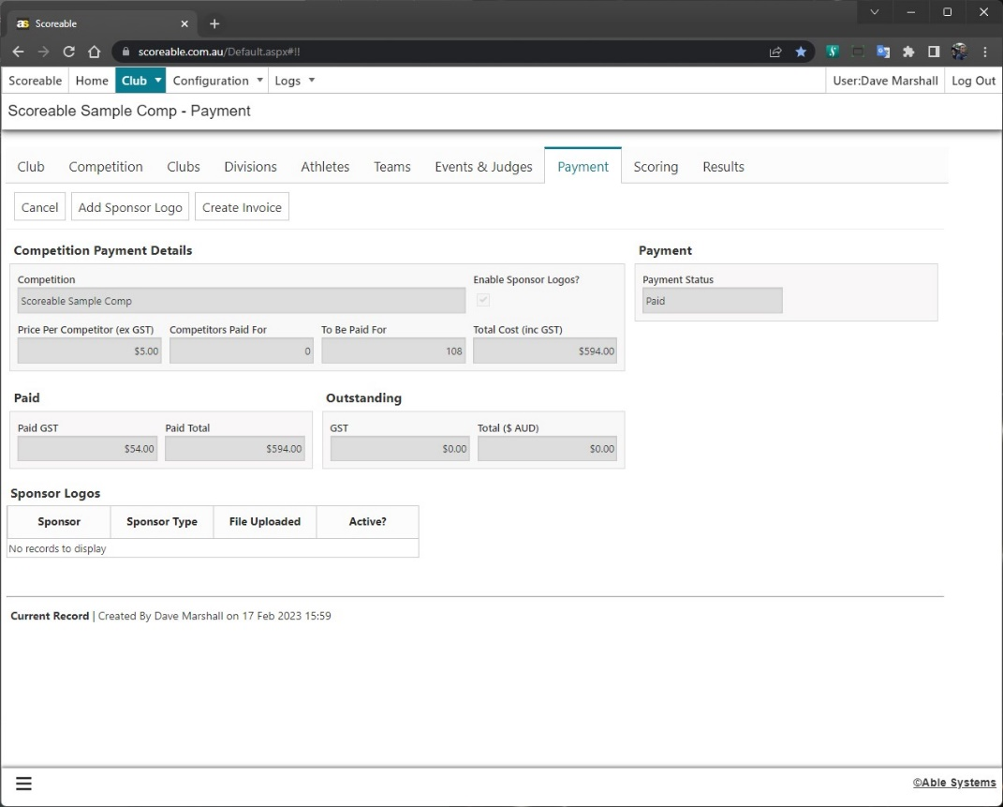
21. Sponsor Logos  If Sponsor Logos are enabled and Payment is complete, an “Add Sponsor Logo” button will appear on the Payment tab  Click “Add Sponsor Logo”  Enter the Sponsor name and type, then click “Add File”  Upload the Sponsor Logo, preferably a .jpg file at least 1000px wide or high  Primary Logos are shown continually throughout the Competition  Secondary Logos are only shown after a Score is displayed  Note: to deactivate a logo during the Competition, uncheck “Active?”, Save and refresh the Scoreboards. ie. if you have a specific Session Sponsor | 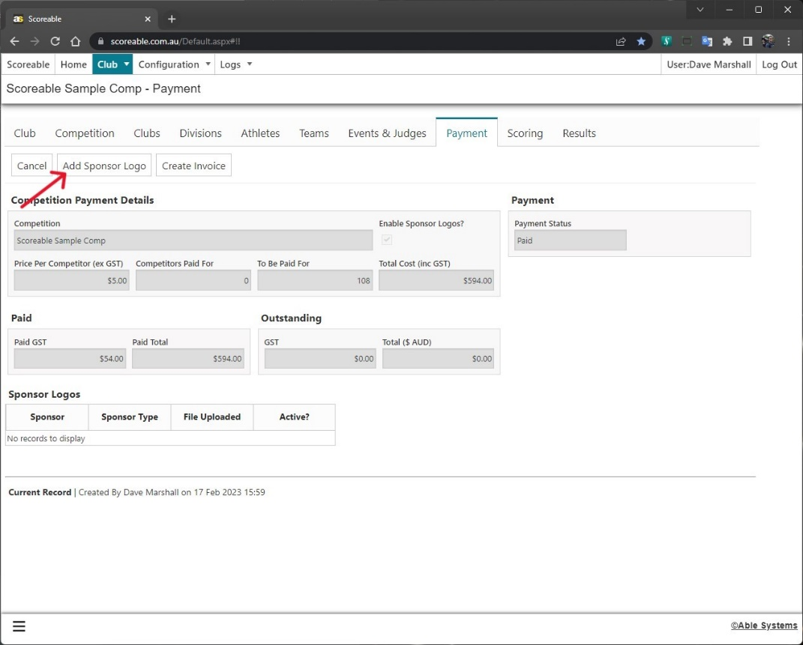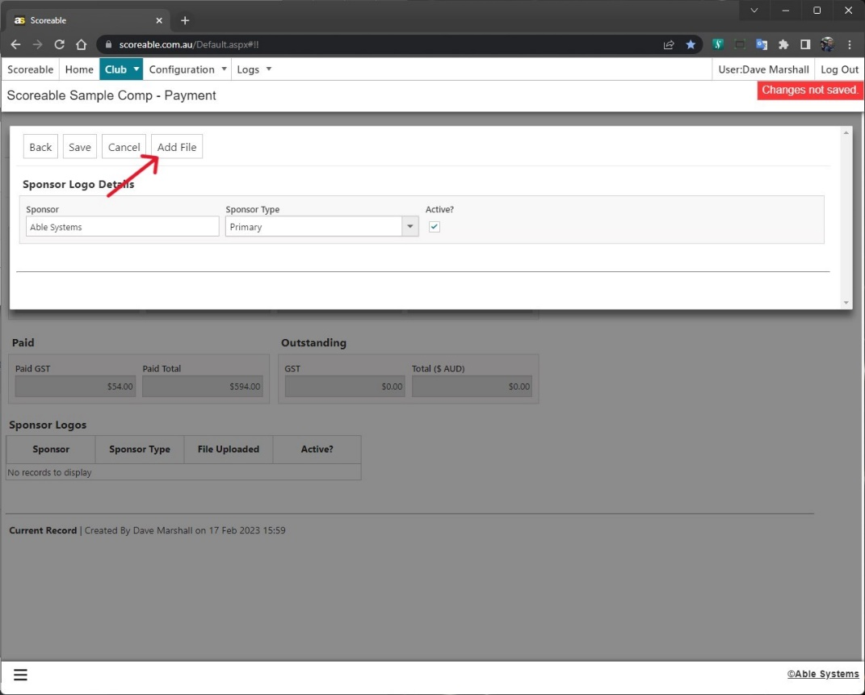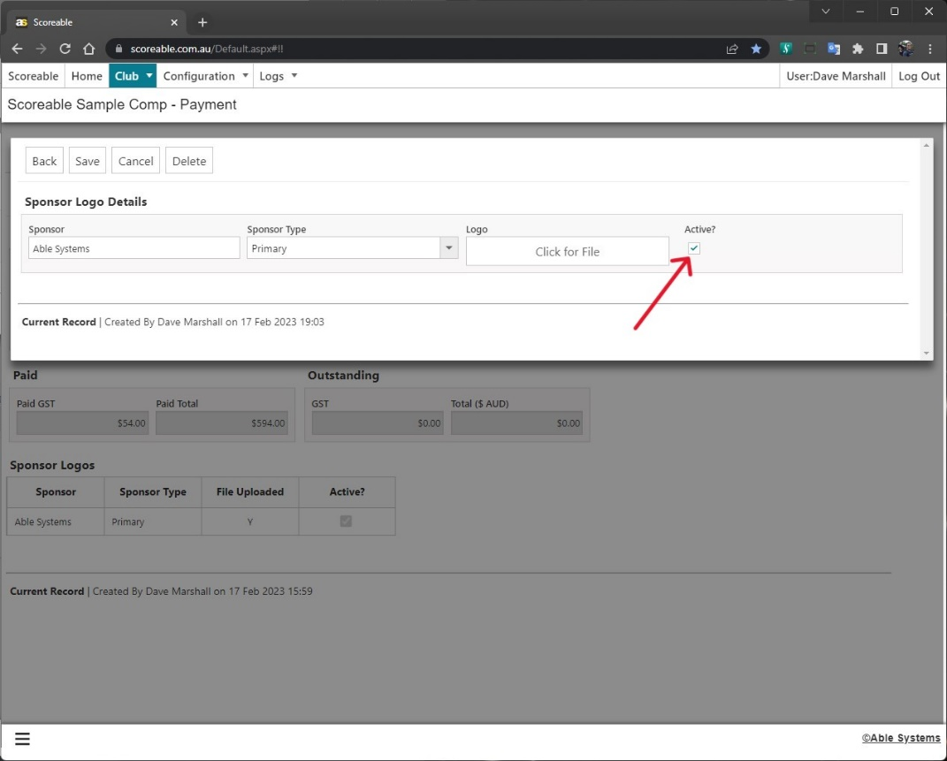

Scoring with Scoreable
Owner | Scoreable
Responsible | Competition Scoring Office
Step | Screenshot
1. Select a Session  Select the relevant Session from the Competition tab | 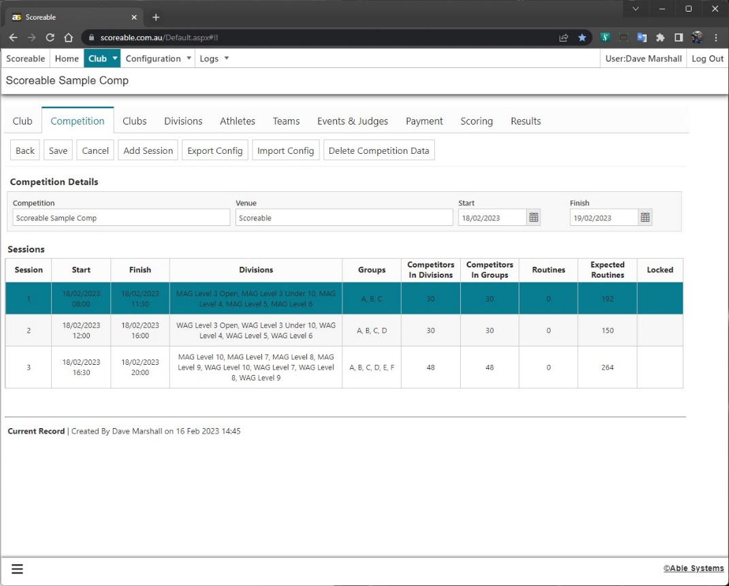
2. Create Scoresheets  Click the “Create Scoresheets” button  An Excel file will be generated and downloaded. Open the file  Note: Competitors are rotated through the Events (first → last), but as the system does not know where the groups will be starting, this is done in Olympic order | 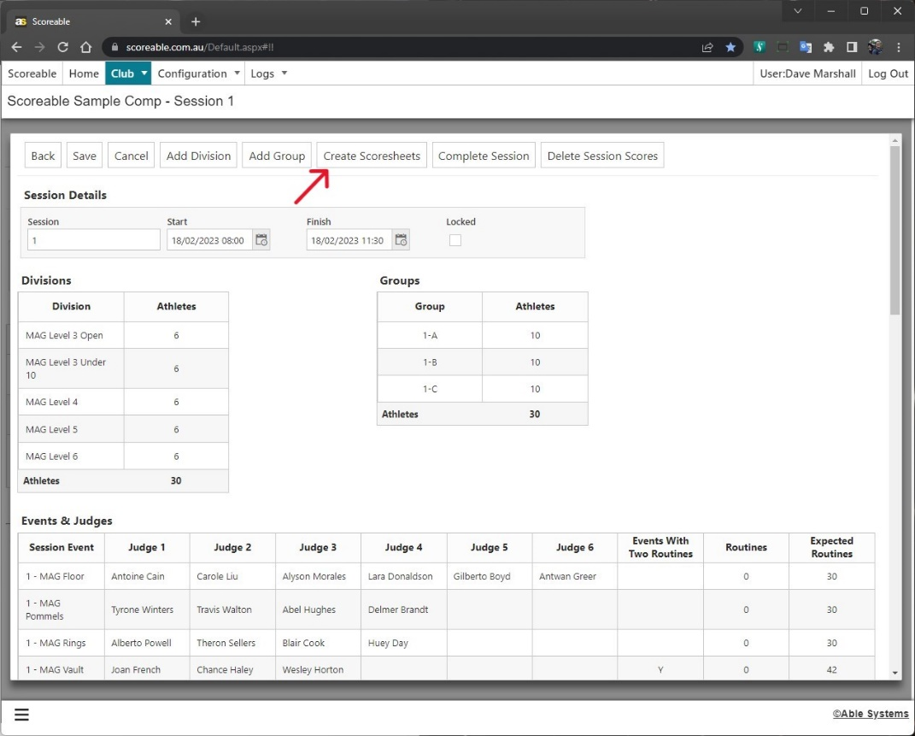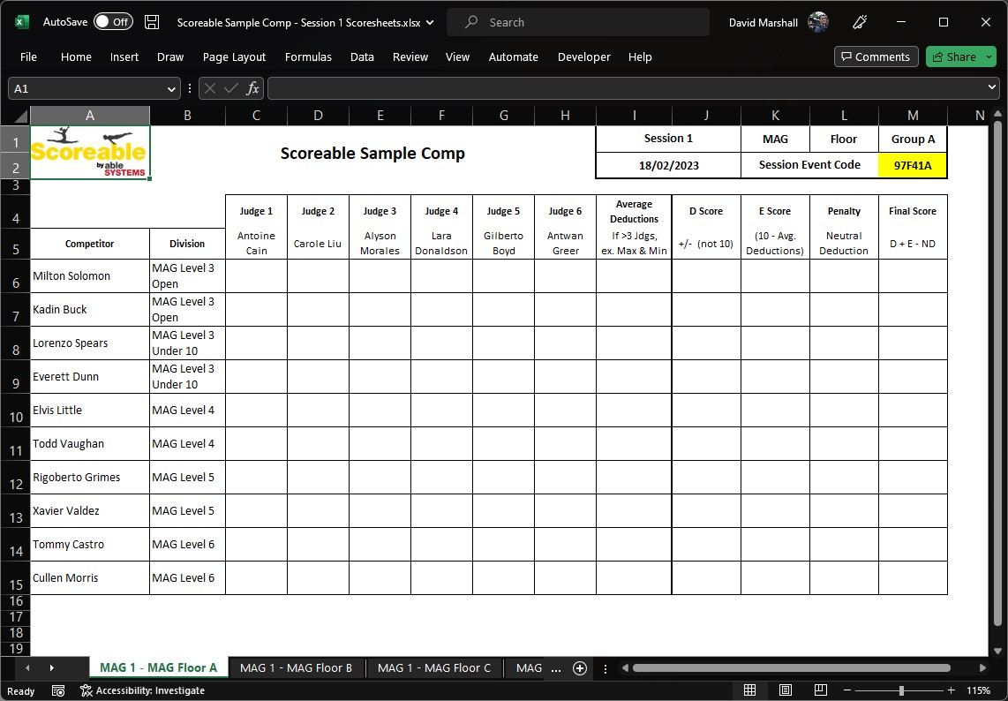
3. Print Scoresheets  Go to File → Print  Change the settings to Print Entire Workbook | 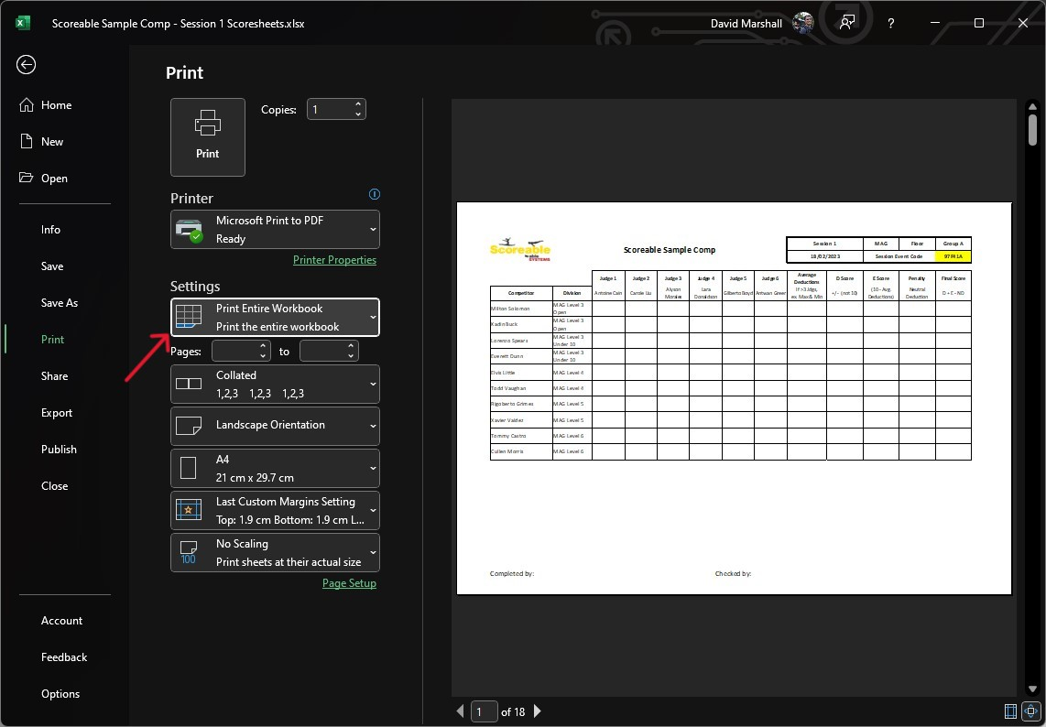
4. Get the Scoreable App  Download the Scoreable app from the App Store or Google Play or | 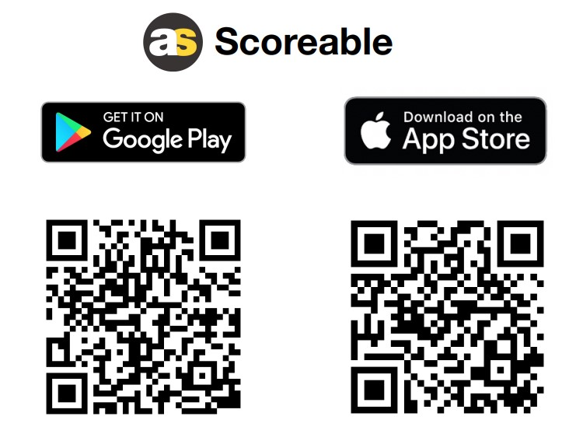
5. Score Entry  Tap on Score Entry | 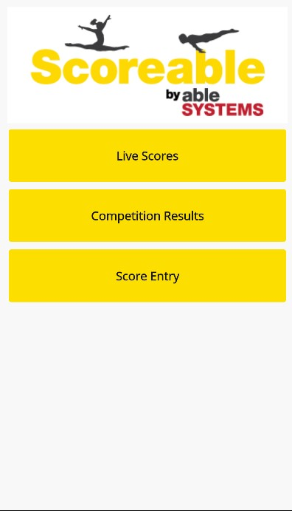
6. Enter Session Event Code  Find the Session Event Code at the top of the scoresheet for the current Group.  Enter this into the app and tap Enter  Note: The code is unique to each Session Event Group | 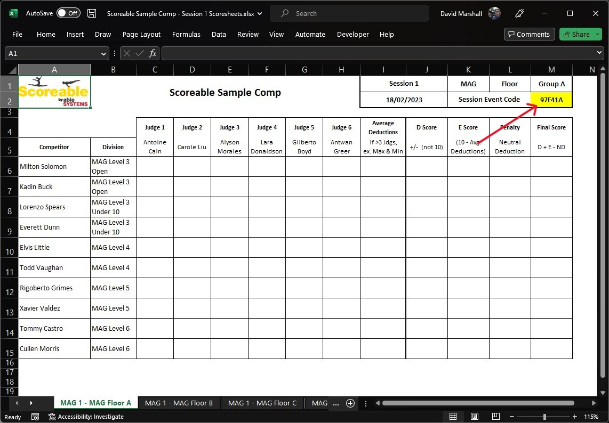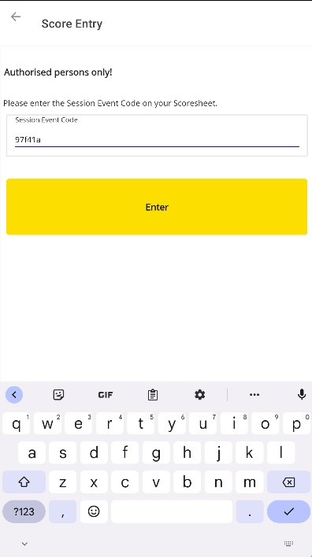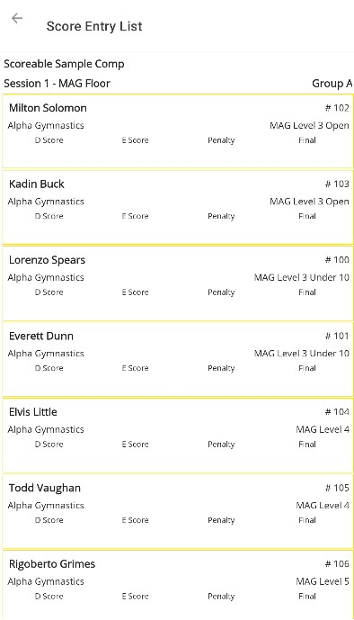
7. Fill out the Scoresheet  Averagers should populate the scoresheet with as per normal | 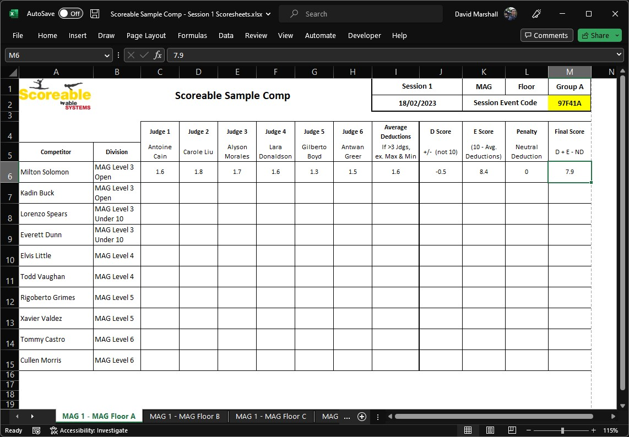
8. Enter Scores in Scoresheet  Tap on the competitor in the App  Enter the Judge scores, D Score and Penalty  Click Calculate  Click Save  Scores can only be entered once via the App. Any changes must be made by the Scoring Office  Note: D Score is not the Start Value | 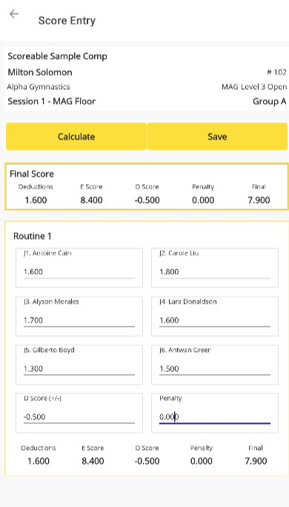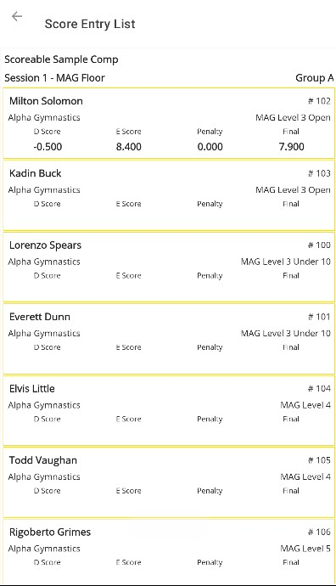
9. Scoring Office Checks  Once the Scoresheet is complete, the Scoring Office should use the Scoring tab to verify the data is entered correctly and update if required | 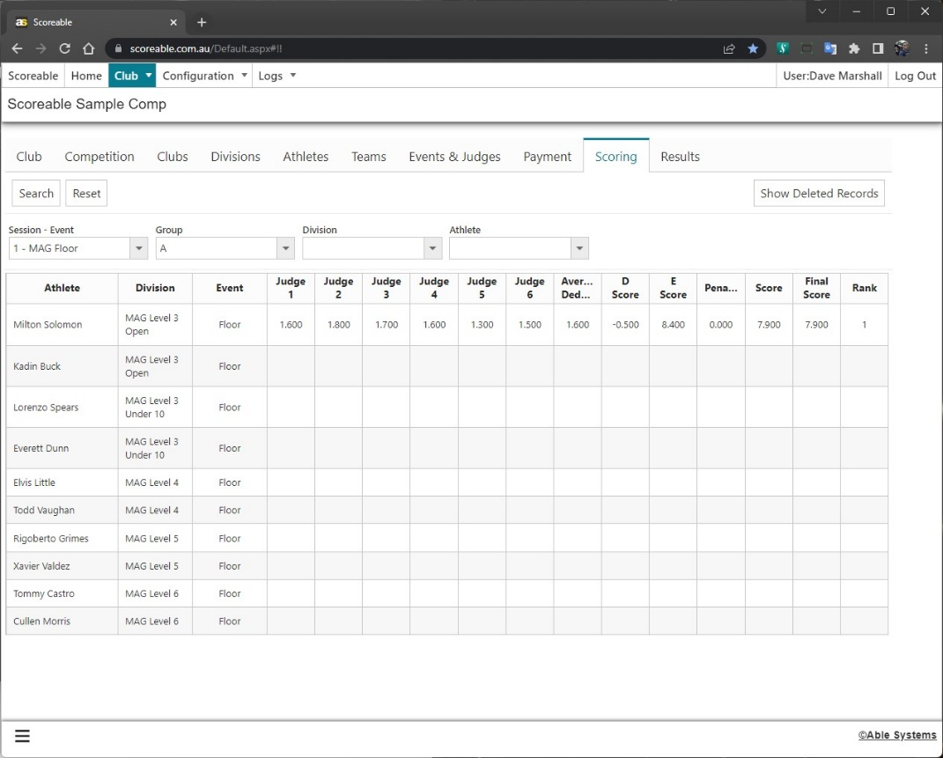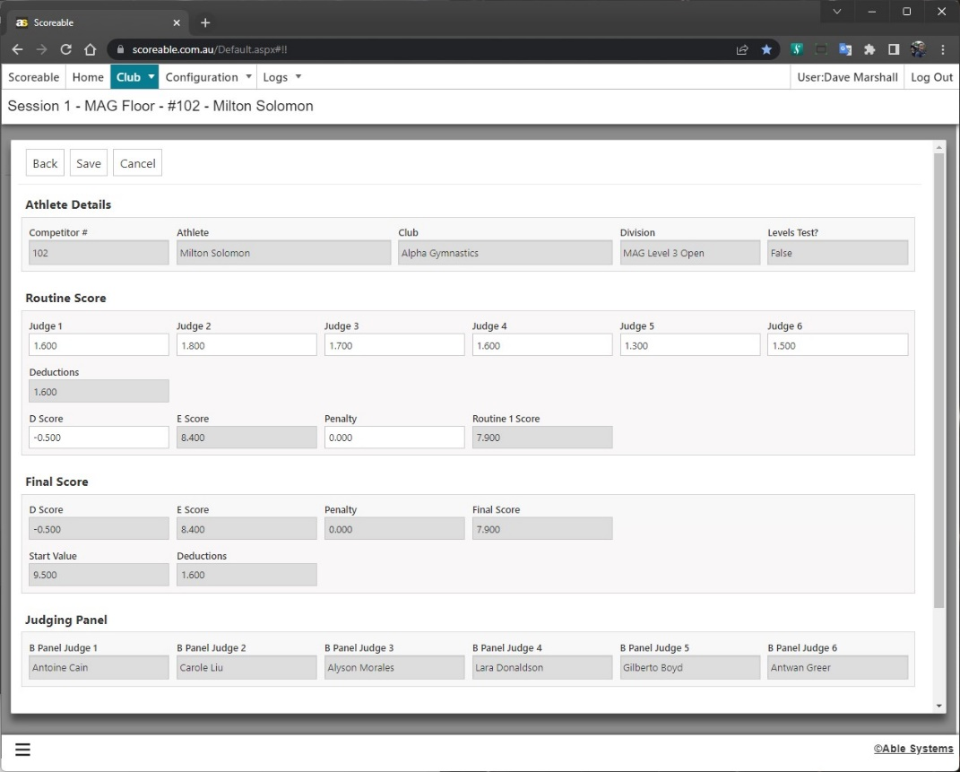
10. Results  The Results will display the entered Scores | 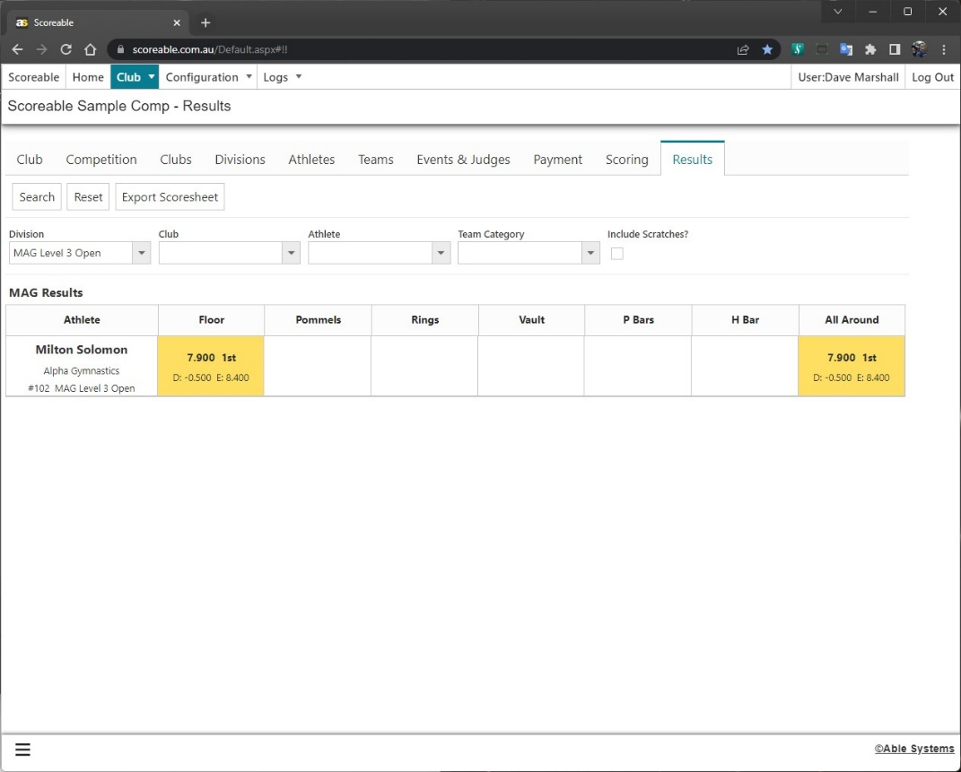

Display Scoreboard
Owner | Scoreable
Responsible | Club Competition Manager / Public
Step | Screenshot
Open Scoreable website  Go to scoreable.com.au and click on “Open Scoreboard” | 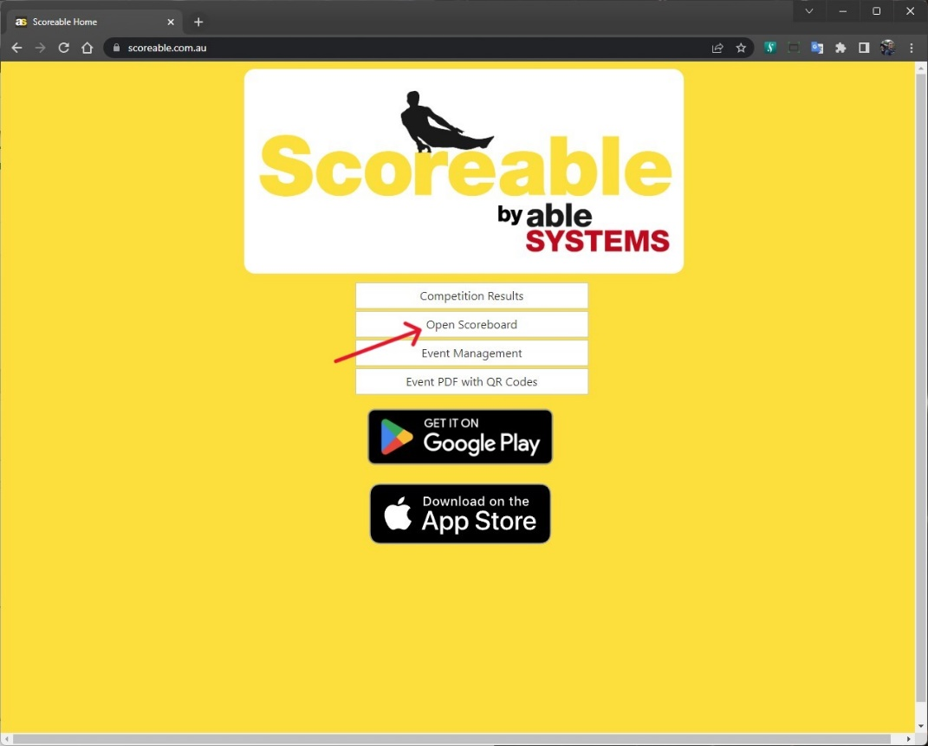
Configure Scoreboard  Select the Competition  If the Scoreboard is for a specific Event, select that also  Note: The list of Competitions is based on the Start and Finish dates entered the Competition setup. Adjust as required if you’re testing | 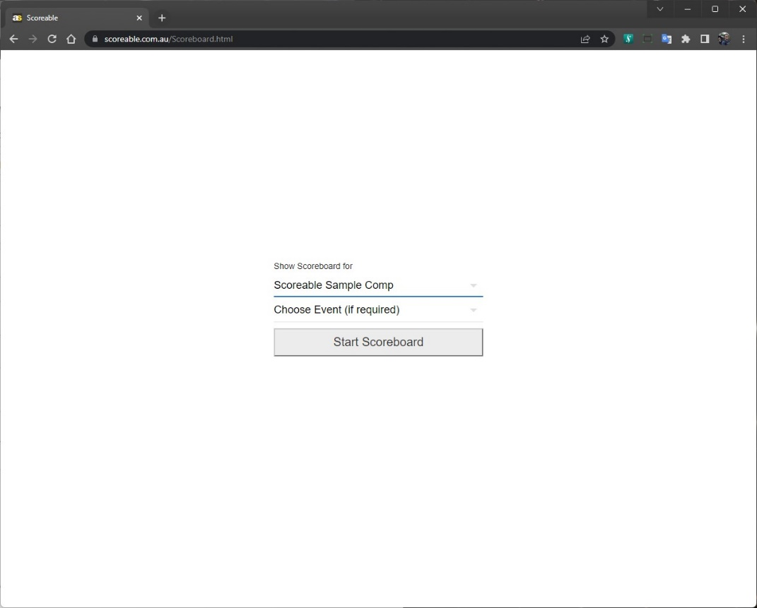
Start Scoreboard  The Scoreboard will poll the server for new scores every 5 seconds.  If a new score is found it will be displayed for 10 seconds.  If Sponsor Logos have been enabled and uploaded the will be cycled through.  Primary Logos will be cycled continuously  Secondary logos will be displayed after each score  If Sponsor Logos have not been enabled, the Scoreboard will cycle through the Scoreable logos  Note: if Casting from a PC, set the windows to full size before Casting | 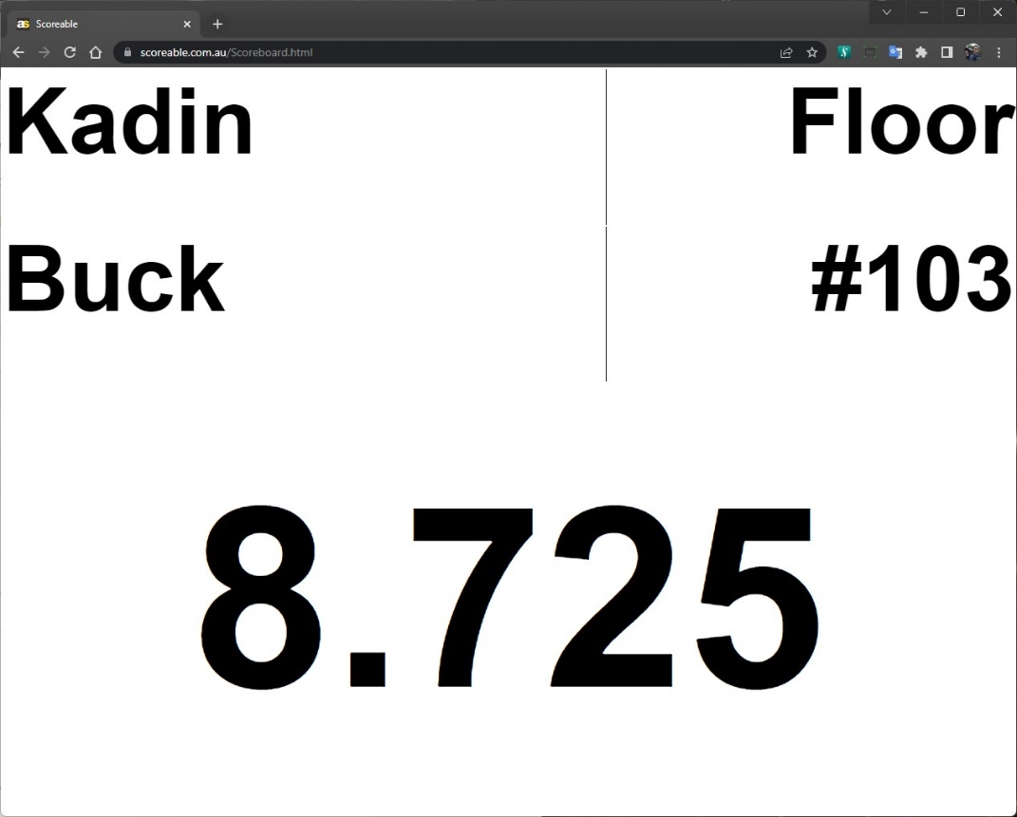
Sponsor Logo  If logos are deactivated during the Competition, just refresh the Scoreboard and the new logos will be downloaded. | 